Power BI is a data analysis and data visualization tool developed by Microsoft. It allows users to connect to a variety of data sources, create interactive reports and charts, and share those analyzes with others.

Here are some key features of Power BI:

1. **Data connection** : Power BI supports connection to many different data sources such as Excel, SQL Server, Azure, Google Analytics, and many other services.
2. **Transform data** : The Power Query tool in Power BI allows users to transform, clean, and prepare data before creating reports.
3. **Data visualization** : Power BI provides a variety of charts and graphs so users can visualize data effectively.
4. **Reports and Dashboards** : Users can create detailed reports and dashboards to track important metrics.
5. **Share and collaborate** : Reports and dashboards can be shared with colleagues or published on the web through Power BI Service.
6. **Integration with other Microsoft tools** : Power BI integrates well with other Microsoft tools such as Excel, SharePoint, and Teams, facilitating collaboration and information sharing.

Power BI has two main versions:

1. **Power BI Desktop** : A free application that allows creating reports and dashboards on personal computers.
2. **Power BI Service** : A cloud service that allows sharing and viewing reports and dashboards from anywhere.

Power BI also has mobile versions that allow users to view reports and dashboards on mobile devices.

Here, we will use Power BI Desktop

First, download Power BI for Desktop:

<https://www.microsoft.com/en-us/download/details.aspx?id=58494>

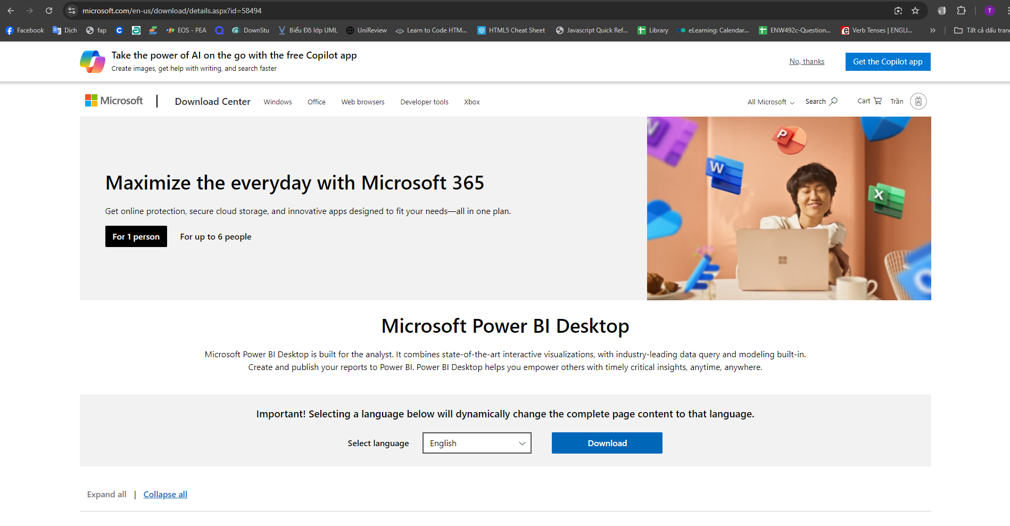

Select language

Select Next

next

next

Install

After successful installation, open Power BI Desktop

Select SQL Server

Enter the SQL Server database name, select OK

Select the tables you want to use and Load

You can Transform Data to filter data before entering Power BI

After the data has been imported, you will see tables in the Data column on the right, and you can use the charts available in the Visualizations section to visualize the data.

For example, for a column chart, I want to get the total transaction amount of each person, drag and drop the data fields of the tables onto the X-axis or Y-axis in the Visualizations column.

Drag the FullName column from the AspNetUsers table to the X-axis, the Sum of Mount column from the Transactions table to the Y-axis

You can use many more charts to visualize data

End!